Infectious moods: How bugs control your mind
FEELING happy? Down in the dumps? Or been behaving strangely lately? Besides the obvious reasons, whether or not you are happy or sad, or prone to depression or other mental illnesses, could be a consequence of an infection - or even down to the diseases that you didn't catch during childhood.
"It used to be thought that the immune system and the nervous system were worlds apart," says John Bienenstock of McMaster University in Hamilton, Canada. Now it seems the immune system, and infections that stimulate it, can influence our moods, memory and ability to learn. Some strange behaviours, such as obsessive compulsive disorder, may be triggered by infections, and the immune system may even shape our basic personalities, such as how anxious or impulsive we are. The good news is that understanding these links between the brain and immune system could lead to new ways of treating all kinds of disorders, from depression to Tourette's syndrome.
This is a massive shift in thinking. Not so long ago, the blood-brain barrier was thought to isolate the brain from the immune system. The cells that make up the walls of blood capillaries are joined together more tightly in the brain than elsewhere in the body, preventing proteins and cells getting into the brain. Now, though, it is becoming clear that antibodies, signalling molecules and even immune cells often get through, sometimes with radical effects. In fact, immune cells do not even need to reach the brain to influence it. Here we look at some of the effects they can have.
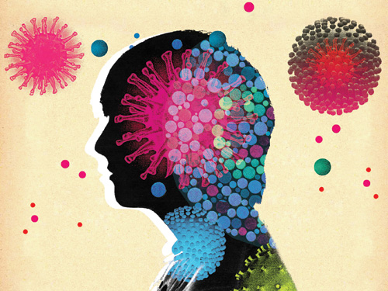Afbeelding 1: The brain is supposed to be isolated from the immune system – but now it seems that happiness, depression and even mental illness really can be catching (Image: Jimmy Turnball)

Infectious moods: A depressing side effect
Chemical messengers from the immune system can wreak emotional havoc if they cross into the brain – even in people who otherwise seem healthy
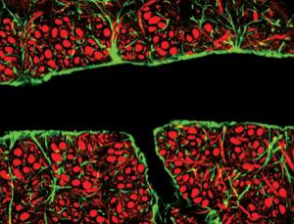Afbeelding 2: The blood-brain barrier (green) turns out to be leaky (Image: C. J. Guerin/MCR Toxicology Unit/SPL)
When we get sick, we often feel lethargic and lose our appetites. Our concentration suffers and we might feel anxious, depressed or anti-social. These changes are caused by signalling molecules called cytokines, which are released by immune cells in response to stress and infection.
Although cytokines are too large to pass freely through the blood-brain barrier, recent studies have shown that they can enter through naturally occurring leaky regions and via specialised channels. They can also affect nerves that transmit signals into the brain.
There is growing evidence that cytokines associated with inflammation can cause depression. For instance, if you inject a healthy person with interferon-alpha, an antiviral drug that prompts the release of inflammatory cytokines, they will begin to show symptoms of depression (Brain Behavior and Immunity, vol 23, p 149).
"Cytokines can interact with virtually every pathway relevant to depression," says Andrew Miller of Emory University School of Medicine in Atlanta, Georgia. And the idea that inflammation induces behavioural changes makes evolutionary sense too, he says. "Cytokines are trying to shut your body down so that you can devote your resources to healing. But at the same time, a wounded animal is a target so it needs to be hyper-alert in case a predator comes onto the scene."
Miller also recently imaged the brains of patients receiving interferon-alpha to treat hepatitis C. His team found the drug activated the dorsal anterior cingulate cortex, a brain region involved in error detection and conflict monitoring (Biological Psychiatry, vol 58, p 190). Similar patterns of activation have been observed in people who are highly neurotic and have obsessive compulsive behaviour. "If you get increased activity in that area of the brain, people tend to be more suspicious and perhaps interpret innocent remarks as threatening," says Miller.
Besides infections and toxins, stress and obesity can also trigger the release of cytokines. "Obese people are two to three times more likely to be depressed, and adipose tissue is a potent source of pro-inflammatory cytokines," says Rook.
For this reason, Rook believes that the immune system may well be affecting the behaviour and mental well-being of even apparently healthy people. "There are an awful lot of people going around with chronically raised inflammatory responses," he says. "It seems likely that they will be suffering some effects."
The effects of cytokines are not all bad, though. Naiomi Eisenberger at the University of California in Los Angeles and her colleagues have found that some people become more sensitive to social pain when they are injected with a bacterial toxin that also boosts inflammatory cytokines. In particular, a cytokine called IL-6 seems to boost activity in brain regions involved in empathy (Neuroimage, vol 47, p 881).
Findings like these could lead to new treatments. A trial is underway to see whether a drug that blocks one of the key inflammatory cytokines, TNF-alpha, can alleviate depression, while other trials are investigating whether common anti-inflammatory drugs such as cox-2 inhibitors or aspirin might improve people's response to conventional antidepressants.

Infectious moods: T-cell recall
The decline in our memories in old age could be partly due to the ageing of immune cells, opening up new prospects for treatments
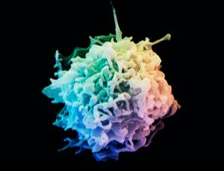Afbeelding 3: MLook after your T-cells (Image: Science Faction/Getty)
Could boosting the immune system keep your memory sharp as you age? Jonathan Kipnis of the University of Virginia in Charlottesville thinks so.
Prompted by studies suggesting immune responses can help repair the nervous system, Kipnis and his colleagues created mice that lack CD4 cells, a kind of T-cell. They found the mice performed extremely poorly in tasks involving learning and memory, but when they were injected with CD4 cells from healthy mice, their memories improved (Proceedings of the National Academy of Sciences, vol 101, p 8180). Similarly, when he killed CD4 cells in healthy mice, their memory declined.
Further animal studies by Kipnis and others show that learning new tasks triggers a mild stress response within the brain, which prompts CD4 cells to rally to the meninges, the membranes that surround the brain. Here, they release IL-4, which both switches off the stress response and tells brain cells called astrocytes to release brain-derived neurotrophic factor, a protein that enhances learning (Journal of Experimental Medicine, vol 207, p 1067).
Whether these animal studies are relevant to human learning and memory remains unclear, but there is some indirect evidence to support it. For example, many chemotherapy drugs suppress the immune system, which might explain why some people with cancer develop "chemobrain" - a term used to describe the cognitive problems and memory loss associated with chemotherapy.
Sluggish immune cells might also explain why our brains slow down as we age. "The number one cell affected by ageing is the T-cell," says Kipnis. "I'm not saying it's the only factor leading to age-related dementia, but it could definitely be one of them."
If the immune system does play a role in human memory, this could lead to new classes of drugs to boost it. Kipnis is already developing such immune-based cognitive enhancers in mice, with the short-term goal of using them to treat Rett syndrome - a developmental disorder associated with behavioural problems that has recently been linked to abnormal T-cells.
Ultimately, Kipnis believes such drugs could be used not only to reverse age-related cognitive decline, but also to boost memory in healthy people. "If you take a very smart human being you may not be able to make him smarter, but if you take someone who is just normal then you may be able to enhance memory," he says.
Others are reserving judgement for the moment. "I think these experiments are very intriguing," says Bienenstock. It's hard to believe that the immune system and the nervous system do not effect each other, he says, but the extent to which this happens is unclear. And even if Kipnis is right, the dangers of meddling with the immune system mean we need to know what we are doing before trying to boost people's memory this way.

Infectious moods: The happiness injection
Down in the dumps? A shot of friendly bacteria could give you the boost you need
It was meant to be a new way to fight cancer. The idea was that injecting a certain bacterium into people would stimulate their immune systems to destroy tumours. Unfortunately, the treatment had little effect on the survival of the terminally ill lung cancer patients in the first trial. It did have one unexpected effect, though: those injected with the bacterium experienced a radical improvement in their mood and quality of life.
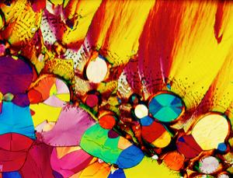Afbeelding 4: A boost of serotonin (Image: Michael W. Davidson/SPL)
"It was supposed to be a double-blind study, but the investigators could nearly always tell who was on the genuine treatment because their whole attitude, their demeanour, changed," says Charles Akle, chair of Immodulon Therapeutics in London, UK. "They just looked better."
How can injecting a bacterium brighten someone's mood? We don't yet know all the details, but animal studies suggest that the immune response triggered by Mycobacterium vaccae causes neurons in the prefrontal cortex to release large amounts of serotonin, boosting mood and well-being (Neuroscience, vol 146, p 756). This might seem odd, given that immune stimulation can also lead to depression (see opposite), but our relationship with M. vaccae goes back a long way. Such "old friends" are thought to prime the immune system in interesting ways. "We think M. vaccae is inducing regulatory cells which will dampen down and terminate unwanted inflammatory responses," says Graham Rook of the Royal Free and University College Medical School in London.
Whatever the mechanism, the discovery adds to the growing evidence that bacteria affect our mind as well as our body. "Bacteria and bacterial products can clearly have an effect on the brain and pathways leading to the brain," says Bienenstock. "There are quite a few papers now suggesting that you can influence behaviour, and that the microbiome has something to do with cortisol production, which are pretty hard-core, basic human reactions to stress and things like that."
In fact, Rook recently proposed that one reason depression is so prevalent in western countries is because people are no longer routinely exposed to organisms like M. vaccae during early life. The "hygiene hypothesis" was originally proposed to explain soaring rates of asthma and allergies, but Rook believes it could also be implicated in psychiatric disorders (Trends in Immunology, vol 29, p 150).
So could M. vaccae be used to make people happy? It is much harder to get approval to inject live bacteria into people with depression than those with terminal cancer, so Immodulon's next trial will be in people with prostate cancer. If there is a strong mood-boosting effect again, the company may focus more on its potential for treating depression. Ultimately, if the precise mechanism can be uncovered, it might be possible to develop drugs that mimic the bacterium's effect.

Infectious moods: Bugs that cause bizarre behaviour
Sometimes it takes antibiotics, not a psychologist, to cure strange obsessions
Sammy Maloney was a healthy, outgoing 12-year-old, who played in the school band, and liked nothing better than to dump his backpack after school and hang out with his friends in Kennebunkport, Maine. Then, in 2002, Sammy's personality began to change. "The first thing I noticed was that he was walking around the backyard with his eyes closed," says Sammy's mother, Beth Maloney. "I asked him what he was doing, and he said he was memorising."
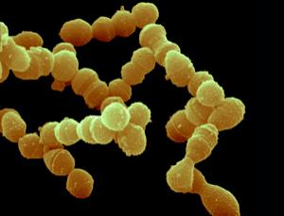Afbeelding 5: In rare cases streptococcus infections can cause severe personality changes (Image: Juergen Berger/SPL)
The next day, Sammy was again walking with his eyes closed and would only use the back door. Then he progressed to holding his breath while doing it, only wearing certain coloured clothes, and refusing to allow the windows to be opened, or the lights to be switched off. "Every single day was a new behaviour," says Beth. "We went from baseline to completely dysfunctional within a period of four to six weeks."
Sammy was diagnosed with obsessive compulsive disorder, and then Tourette's syndrome. When he continued to deteriorate, a friend suggested testing Sammy for streptococcus - a common childhood bacterial infection that usually causes no more than a sore throat. "By this point he was totally emaciated and he was covered with scabs from scratching himself," says Beth.
Sammy hadn't shown any signs of streptococcal infection, but it turned out he was infected. When doctors prescribed antibiotics, his symptoms began to improve. Within a few weeks he was playing board games with his brothers. "After six months of treatment, I knew that he would recover," says Beth.
Sammy remained on antibiotics for four years, as every time the dose was reduced he had a relapse. Now aged 20, Sammy has none of the compulsions that blighted his youth.
Madeline Cunningham at the University of Oklahoma in Oklahoma City says that, although extreme, Sammy's story isn't that unusual. She has spent years investigating behavioural disorders linked to childhood streptococcal infection, including Tourette's syndrome, an OCD-like disorder called PANDAS, and the movement disorder Syndenham's chorea, which is associated with tics and an inability to control emotions.
Cunningham has shown that, at least as far as Sydenham's chorea is concerned, antibodies against one group of streptococcal bacteria can bind to receptors in an area of the brain that controls movement. Here they mimic the effects of natural signalling molecules, triggering the release of the neurotransmitter dopamine, which may explain the tics and emotional problems experienced by children with the disorder (Autoimmunity, vol 39, p 21).
Not every child with PANDAS has similar antibodies, but for those that do antibiotics or drugs that suppress the immune system are effective treatments, says Cunningham. Preliminary evidence also links such antibodies to Tourette's syndrome.
Cunningham stresses that there is no evidence that vaccination can trigger disorders like PANDAS. "You're more likely to get this from not being immunised," she says.
Meanwhile, Betty Diamond of the Feinstein Institute for Medical Research in Manhasset, New York, has also shown that antibodies associated with the autoimmune disease lupus can get into the brain and kill neurons by binding to NMDA receptors. This might partly explain the mood changes and cognitive decline associated with the disease.
Mouse studies suggest how behaviour is affected depends on what makes the blood-brain barrier leak, as well as on the antibodies themselves. When the barrier is compromised by inflammation, lupus-related antibodies damage the hippocampus, impairing memory. When the barrier is breached by stress hormones (adrenaline), the antibodies damage the amygdala, making individuals more fearful. The results were presented at a meeting of the American Association of Immunologists in Baltimore in May last year.
"This could change the way we treat mental disorders forever," says Cunningham, who thinks antibodies influence the behaviour even of apparently healthy individuals. "Your immune system develops based on what organisms it sees, and it could be that your brain does too."
Diamond agrees: "We have tonnes of antibodies even when we don't have clinical disease. I'm sure that some of these are having an effect on the brain."

